Activity 1: Use Case Diagram

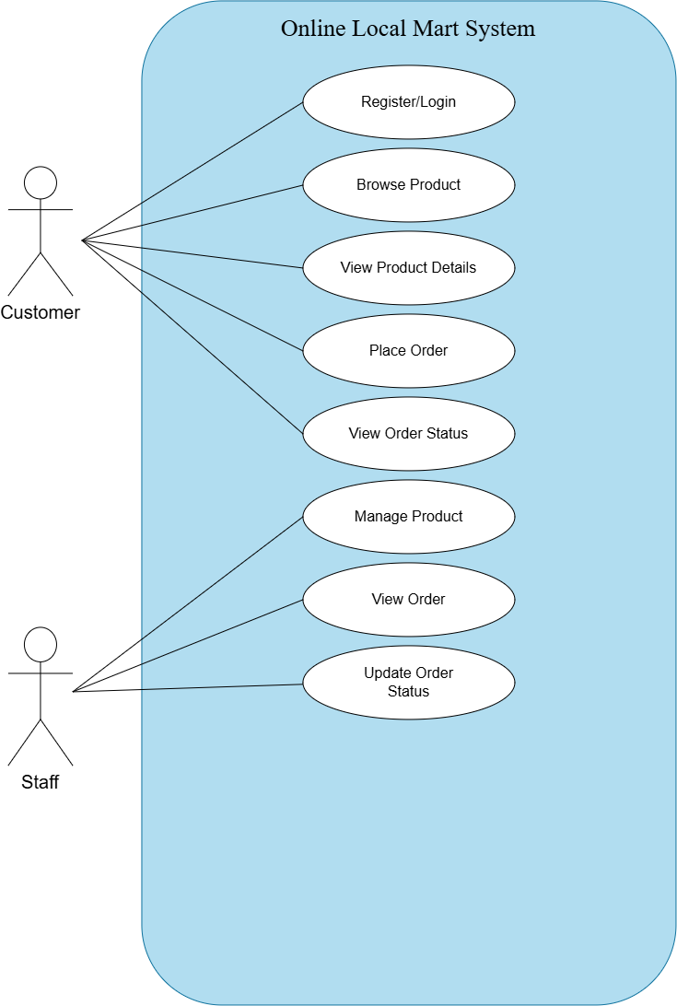
UML Class Diagram
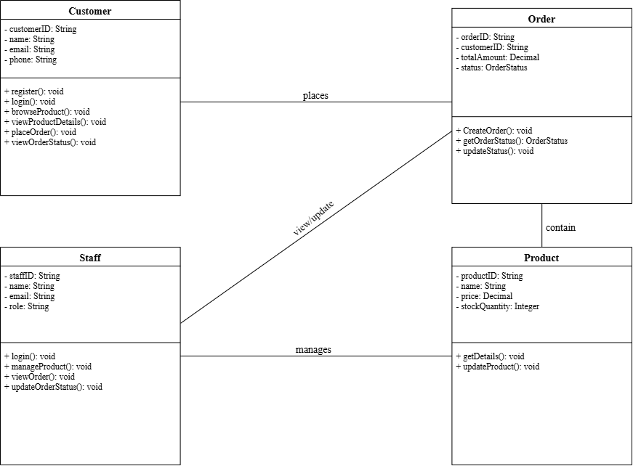

Activity 3(a) Naming Conventions – Dictionary

1. General Architectural Casing Conventions
Element | Notation Style | Standard / Syntax Rule | OLMS Implementation Example
Classes / Entities | PascalCase | Nouns representing primary domain entities matching the UML class definitions. | Customer, Staff, Product, Order
Methods / Functions | camelCase | Verbs or verb-object phrases defining operations and behaviors. | browseProduct(), viewOrderStatus(), updateProduct()
Attributes / Variables | camelCase | Descriptive nouns or compound identifiers specifying state. | customerID, stockQuantity, totalAmount
Constants / Enums | UPPER_SNAKE_CASE | Immutable state definitions and enumerations. | OrderStatus.PENDING, OrderStatus.DELIVERED
Database Tables | snake_case (Plural) | Plural nouns representing persistent relational tables. | customers, staffs, products, orders
Database Columns | snake_case (Singular) | Lowercase identifiers; primary and foreign keys suffixed with _id. | customer_id, product_id, stock_quantity
Source Code Files | PascalCase | Filenames must strictly mirror the class name they encapsulate. | Customer.php / Customer.js, Product.php

2. Domain Entities & Attributes Dictionary
Directly derived from the OLMS UML specification to ensure uniform variable naming across UI forms, backend logic, and database schemas:

Entity | Attribute Name (Code) | Database Column | Data Type | Description
Customer | customerID | customer_id | String / VARCHAR(50) | Unique primary identifier for a customer account.
 | name | name | String / VARCHAR(100) | Full legal name of the customer.
 | email | email | String / VARCHAR(100) | Registered customer email address (unique).
 | phone | phone | String / VARCHAR(20) | Contact phone number for delivery coordination.
Staff | staffID | staff_id | String / VARCHAR(50) | Unique primary identifier for staff/mart admin.
 | name | name | String / VARCHAR(100) | Full name of the staff member.
 | email | email | String / VARCHAR(100) | Official mart personnel email address.
 | role | role | String / VARCHAR(50) | Access role assigned (e.g., Manager, Clerk).
Product | productID | product_id | String / VARCHAR(50) | Unique inventory SKU / product identifier.
 | name | name | String / VARCHAR(150) | Commercial name of the listed product.
 | price | price | Decimal(10,2) | Unit selling price of the product.
 | stockQuantity | stock_quantity | Integer / INT | Current units available in local mart inventory.
Order | orderID | order_id | String / VARCHAR(50) | Unique invoice / order tracking code.
 | customerID | customer_id | String / VARCHAR(50) | Foreign key referencing Customer.customerID.
 | totalAmount | total_amount | Decimal(10,2) | Final calculated financial cost of the order.
 | status | status | OrderStatus (Enum / VARCHAR) | Current delivery/processing status of the order.

3. Method & Function Dictionary
Derived directly from the Use Case actions and UML Class operations:

Method Signature | Class Origin | Access | Return Type | Description / Responsibility
register() | Customer | public (+) | void | Creates and validates a new customer account.
login() | Customer, Staff | public (+) | void | Authenticates user credentials and initiates session.
browseProduct() | Customer | public (+) | void | Queries and displays active products to the customer.
viewProductDetails() | Customer | public (+) | void | Displays granular specifications, stock, and price for a single product.
placeOrder() | Customer | public (+) | void | Converts selected items into a pending customer order.
viewOrderStatus() | Customer | public (+) | void | Fetches the current fulfillment state of customer orders.
manageProduct() | Staff | public (+) | void | Coordinates CRUD operations over the product inventory.
viewOrder() | Staff | public (+) | void | Retrieves orders across the mart for processing.
updateOrderStatus() | Staff, Order | public (+) | void | Mutates order lifecycle (e.g., Pending $\rightarrow$ Shipped $\rightarrow$ Delivered).
getDetails() | Product | public (+) | void | Returns internal product properties for viewing.
updateProduct() | Product | public (+) | void | Mutates existing product price, name, or stock quantity.
createOrder() | Order | public (+) | void | Instantiates and persists a new order record.
getOrderStatus() | Order | public (+) | OrderStatus | Queries the current enum value of the order status.

4. Prohibited Terminology & Synonyms Rule
To prevent inconsistencies across team pull requests, only the official terms from the diagram may be used:
- Use Customer, never User, Buyer, or Client.
- Use Staff, never Admin, Merchant, Employee, or Seller.
- Use Product, never Item, Good, or Merchandise.
- Use stockQuantity, never qty, count, stock, or amount.
- Use totalAmount, never total, price, cost, or bill.

Activity 3(b): Define Functions and Modularity
Function and Method Modularity
Customer Class
- register() creates a new account for the customer with information such as name, email and phone number.
- login() verifies customer's login details before allowing access to the system.
- browseProduct() Search and display any available products for the customer.
- viewProductDetails() shows detailed information for a selected product, such as product name, price, and stock quantity.
- placeOrder() creates an order after the customer selects products to purchase.
- viewOrderStatus() displays the current status of the customer's order, such as Pending,
- Processing, Shipped, or Completed.
Staff Class
- login() verifies staff login credentials.
- manageProduct() coordinates product management tasks, such as adding, editing, or removing a product.
- viewOrder() retrieves and displays customer order information for staff.
- updateOrderStatus() changes the status of an order after it has been processed.
- Product Class
- getDetails() returns the details of a product for customers or staff to view.
- updateProduct() updates product information, such as the product name, price, or stock quantity.
Order Class
- CreateOrder() creates a new order when a customer places an order.
- getOrderStatus() returns the current order status for the customer or staff.
- updateStatus() changes the order status when staff process the order.

Activity 4: Define Communication and Continuous Integration Rules

a. Communication Rules
Category | Policy / Standard | Operational Details
Communication Channels | Centralized Platform | All project-related communication should be conducted through the agreed team communication platform.
Task Management | Issue Tracking via GitHub | GitHub Issues should be used to report bugs, assign development tasks, and track project-related problems.
Defect Reporting | Structured Issue Descriptions | Team members should clearly describe the issue, expected outcome, and relevant module when creating an issue.
Progress Reporting | Transparency & Updates | Team members should provide regular updates on their assigned tasks and inform the team early about any problems or delays.
System Decisions | Prior Technical Consensus | Technical decisions that affect the system architecture, database, coding standards, or development workflow should be discussed with the team before implementation.
Pull Request Content | Clear Context & Traceability | Pull Requests should include a clear description of the changes made and the related issue or task where applicable.
Code Review | Mandatory Peer Review | Team members should review and respond to Pull Request comments before the code is merged.
Knowledge Base | GitHub Documentation | Important project decisions and changes should be documented in GitHub so that they can be referred to by all team members.
Domain Standards | Dictionary Alignment | Team members should use the approved domain terminology consistently, such as Customer, Staff, Product, Order, stockQuantity, and totalAmount.
Workflow Governance | Standard Alterations | Any changes to the agreed coding standards, system structure, or development workflow should be communicated to the entire team.

b. Continuous Integration Rules
Pipeline Stage | CI Standard | Enforcement Criteria
Branching Strategy | Isolated Feature Branches | All new features and fixes must be developed using a separate feature branch.
Branch Protection | Protected Primary Branches | Developers must not directly push changes to the main or dev branches.
Staging Workflow | Targeted Pull Requests | Completed features must be submitted through a Pull Request to the dev branch.
Review Gate | Minimum Approvals | Each Pull Request must be reviewed by at least one other team member before merging.
Automation Trigger | Automated CI Runs | CI checks must run automatically when code is pushed to a feature branch or when a Pull Request is created or updated.
Build & Test | Integrity Verification | CI must verify that the project can be built successfully and that automated tests, where available, pass successfully.
Quality Gate | Zero-Failure Policy | Code that fails the required CI checks must not be merged until the errors are fixed.
Integration | Staging Verification | The dev branch is used to integrate, and test completed features before they are released to main.
Release Management | Stable Main Branch | The main branch must contain only stable and production-ready code.
Regression Prevention | Core Module Safeguards | Changes merged into dev should not break existing system modules such as Customer, Staff, Product, and Order functions.
Coding Standards | Pre-PR Compliance | Developers should ensure that their code follows the approved naming conventions and modularity rules before creating a Pull Request.
Code Modularity | Function Length Limit | Functions should remain within the agreed maximum of 30 lines unless there is a documented reason for exceeding the limit.
Defect Ownership | Responsible Triage | Any failed CI build or test should be investigated and resolved by the developer responsible for the change.

